

The Jamaica Baptist Union Mission Agency
A production of the Jamaica Baptist Union Mission Agency
Disaster Awareness & Emergency Response Committee

Disaster Awareness and Emergency Response
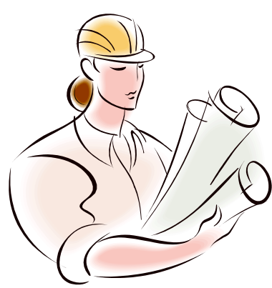

Disaster

PREPAREDNESS

& Recovery

Planning
With Christ in the vessel, we will smile at the storm

Table of Contents

Foreword |  | 3
Endorsements |  | 4
General Hints |  | 6
Hurricane |  | 8
Flood |  | 11
Earthquake |  | 14
Landslides |  | 17
Fire |  | 19
Drought |  | 22
Personal Safety Tips |  | 25
Safe Driving Tips |  | 28

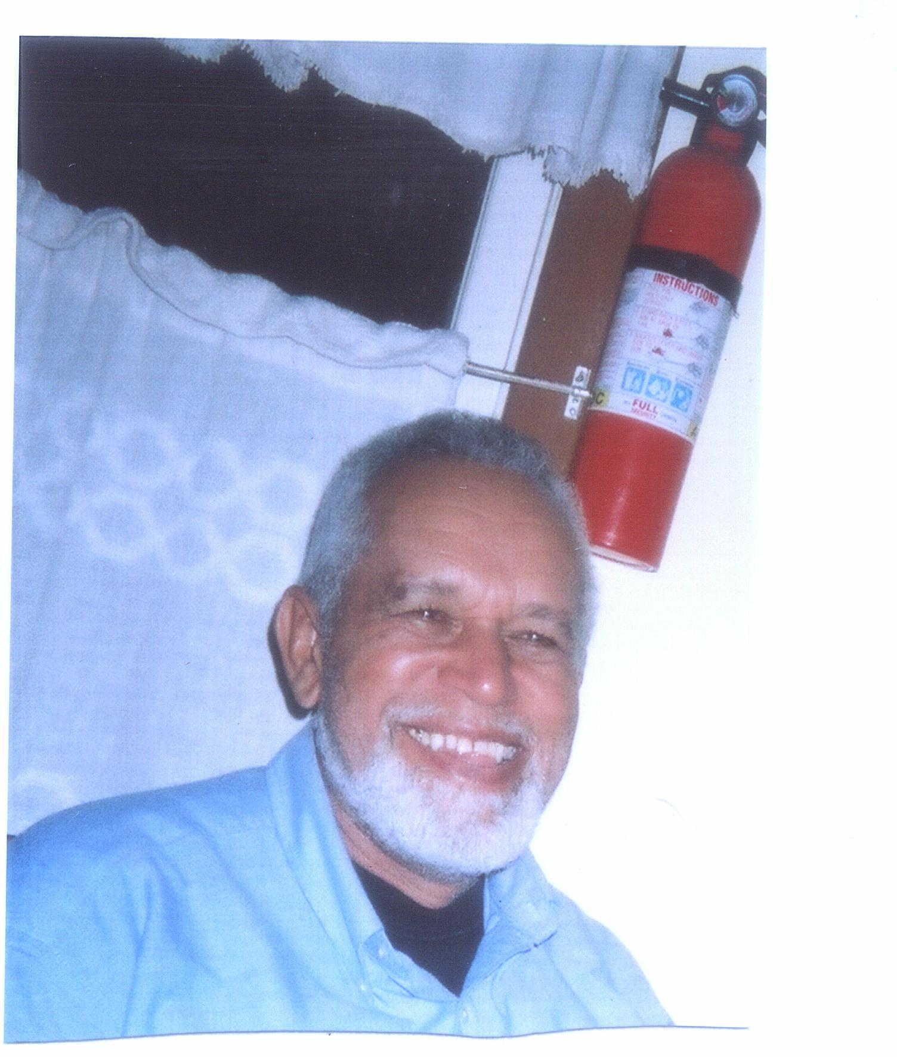
It is my privilege and honour to commend this little booklet to you….the Churches of the JAMAICA BAPTIST UNION and the members of our congregations island wide.
The Committee - Disaster Awareness and Emergency Response (DAER) is a part of the JAMAICA BAPTIST UNION MISSION AGENCY.
Our mandate –as our name implies-is to assist with training and preparation for disasters. Make no bones about it my friends disasters will come. As I write no subject worldwide today is more topical than the recent earthquake in Haiti, killing nearly two hundred thousand persons and leaving much rubble in its wake. We hardly need a more poignant reminder of what Disasters can do.
All of us living in the Caribbean are well aware that for some five or six months each year we face the threat of hurricanes. At other times we face floods, fires, landslides and road fatalities and the like.
It is our hope and prayer that we will become more pro-active in planning and preparing ourselves. At the level of Churches—especially now that we have so many high rise buildings we MUST ask you to engage in Earthquake Drills once or twice per year. Ask any agency near you, like an ODPEM office to assist you in doing your first drill, ensuring that the best method of evacuating the building etc is understood. Likewise we recommend Fire drills and we expect that each Church will invest in a working FIRE EXTINGUISHER-bought and serviced as per the accompanying instructions.
Information in this booklet was gathered from the JBU disaster seminar document, publications from ODPEM and CDERA (Caribbean Disaster Emergency Response Agency) and other general publications such as newspapers etc.
As I close this foreword please allow me to thank the members of the DAER Committee for their contribution in helping to make this booklet a reality. The only compensation that we seek is the assurance that this booklet will be read and kept in a safe and easily available place for reference…helping all of us to respond in a helpful way.
Committee members are: Conroy Daley, Cleve Lazarus, Danielle Redwood & Ken Tucker

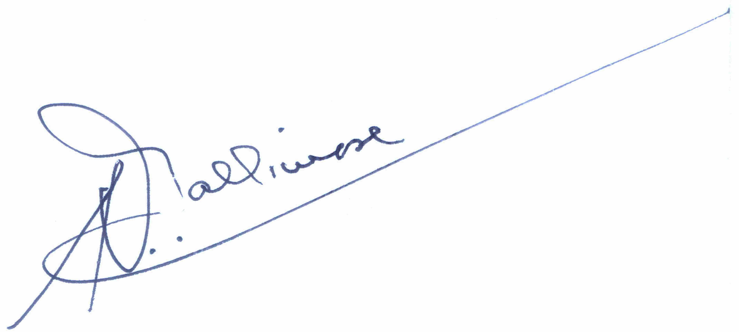
Yours in His Service

Rupert Gallimore
Chairman - DAER Committee
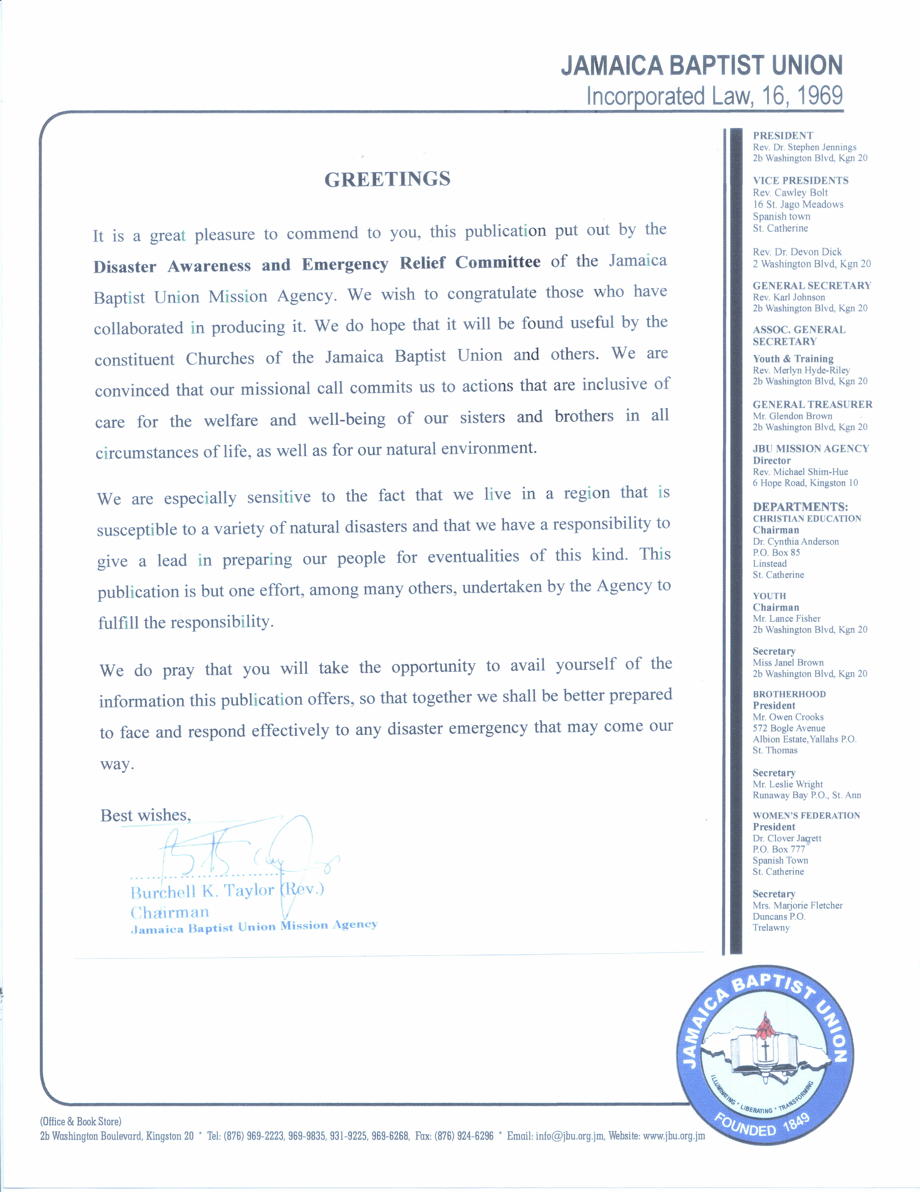
Help to keep our Response Ability Strong
Complete the requested information below and return the form to:
Ms. Danielle Redwood
Jamaica Baptist Union
2B Washington Boulevard
Kingston 20
Disaster Representative Contact Information
Name of Circuit:
Name of Circuit Disaster Rep
Contact Details
Address:
Telephone #:
e-mail:
Help to keep our Response Ability Strong
Complete the requested information below and return the form to:
Ms. Danielle Redwood
Jamaica Baptist Union
2B Washington Boulevard
Kingston 20
Disaster Representative Contact Information
Name of Circuit:
Name of Circuit Disaster Rep
Contact Details
Address:
Telephone #:
e-mail:

STATEMENT FROM THE JBUMA DIRECTOR
COMMENDING THE CHURCHES IN THE UNION RE USE OF BOOKLET
My sisters and brothers of the three hundred and twenty two (322) churches in the Jamaica Baptist Union (JBU), God has been good to us over the past year. Even when those who ought to know predicted a very active hurricane season that would beset the usual countries, it was not so. We however began the year 2010 with the devastating earthquake in Haiti on January 12.
While we continue to pray for and stand in solidarity with our sisters and brothers in Haiti as we have been doing as a Union over the last ten (10) years, we deem the earthquake as a warning to us in Jamaica. You might recall that on the fourth Sunday of May to the last Sunday of May 2009 the Jamaica Baptist Union Mission Agency through its Disaster Agency, The Disaster Awareness and Emergency Response Committee, issued reminders, ideas and tips and other suggestions as to how we might better prepare for, react during and respond to a disaster. In fact, we were reminded that as a people disasters come not only in the form of wind and water, but also in terms of Fire, Motor Vehicle Crashes, Land Slippages, Gas Poisoning and most certainly earthquakes to name a few.
May I appeal to you in the name of Jesus Christ that you take seriously the intent of this booklet as, under God, yet another attempt is being made to make you more aware; to prepare you for; and to equip and enable you to understand and respond to disasters.
May all our churches, on whatever day meetings are held, seize the opportunity to read publicly, disaster tips and engage congregationally in disaster drills.
God bless you,

Michael Shim-Hue, Rev.
Director
JBUMA

You may need to survive on your own after an emergency. This means having your own food, water and other supplies in sufficient quantity to last for say four to five days. Local officials and relief workers will be on the scene after a disaster, but they cannot reach everyone immediately. You could get help in hours or it may take days.
In addition basic services like electricity, cooking gas, water, sewage and telephones may be cut off for days or even weeks.
The following are recommended:
WATER
One gallon of water per person per day for at least three days - for drinking and sanitation purposes.
FOOD
A four to five-day supply of non-perishable food
GENERAL
- Battery powered radio and flashlight (and spare batteries)
- First aid kit (usual essentials) and a whistle to attract attention
- Dust mask and duct tape
- Moist towellettes, garbage bags and cord to tie bags used in sanitation.
- Can opener for foods
- Cell phones charged and with credit
- Prescription medication/eye glasses
- Infant formulas/diapers
- Pet food for pets
- Important documents properly wrapped in plastic bags
- Keep any money you have safely
- Warm blanket
- Bleach and medicine dropper (one part bleach to nine parts water as disinfectant)
- Feminine supplies/personal hygiene items
- Paper cups/plates/towels
- Paper and pencil
- Books/games for children
AT HOME
- Learn to shut off cooking gas/water and electricity
- Secure hanging plants/wall pictures and mirrors
If you are asked to evacuate, PLEASE FOLLOW SUCH INSTRUCTIONS. Unplug appliances before leaving home and turn off cooking gas cylinders. Advise a friend or relative in another location where you are moving to.
AFTER DISASTER
- Do not attempt to use the telephone
- Stay calm—check neighbours especially elderly and children
- Listen to portable radio for information and co-operate with instructions.
- Keep away from downed power lines - do not drive around unnecessarily.
- Conserve use of water…boil water for three minutes before consuming.

Hurricanes are the leading cause of disasters in Jamaica. The term hurricane is used to describe a storm with winds in excess of 75 mph (120 kph). These winds revolve anticlockwise around a calm centre. In addition, hurricanes can be accompanied by heavy rainfall and huge waves.
AT THE START OF THE HURRICANE SEASON
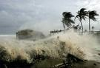
- Check on these emergency items: water, boots, raincoats, flashlights and batteries, battery-powered radio, hurricane lamp, matches, kerosene oil, coal and hurricane shutters.
- Keep plastic bags, nails, hammer and other tools handy
- Have on hand simple first aid supplies
- Stock 4-5 days’ supply of food that does not need cooking or refrigeration
- Make sure you have material for battening up doors and windows
- See that galvanized sheeting on your roofs, out-buildings and fences are securely fastened.
- If your house is in a high risk area, subject to a storm surge (tidal wave) or flooding, be sure you know of a safe shelter; preferably with relatives or friends.
- Trim trees with branches near to buildings or electrical lines. Also pick fruits off trees as these can be carried by the wind and cause further damage.
BEFORE THE HURRICANE
- Keep radio on and listen for the latest warnings and bulletins which will be given via radio and television.
- Emergency cooking facilities (e.g. oil and coal stoves) may be necessary
- Procure supply of kerosene oil and charcoal
- Check that your emergency supplies for cooking and food are in place.
REMEMBER:
- Electricity may be off and you may be without refrigeration for some time.
- Have a flashlight in good working order, keep it handy. Matches, storm lantern, a complete First-Aid Kit and candles are useful
- If you have a car, fill it with gas as it might be needed in an emergency
- Store drinking water in clean containers.
BATTEN DOWN
- Have board or lumber to batten up windows and doors. Also have masking tape to tape glass windows and doors. Use masking tape to form an 'X' on glass windows.
- Put up storm shutters or batten up windows with good boards if you have no shutters.
- Take down television antennae, canvas awnings, satellite dishes and move furniture away from exposed windows and doors.
- Remove all pictures, clocks and other hanging articles from the wall and store them in a safe place.
- Remove all items such as books, figurines etc. from shelves and store in a safe room.
- Put away all objects that can be blown away by the wind and wrap important papers in plastic.
- Wrap all documents and important papers in plastic and store all fluorescent tubes, light bulbs and lamp shades in safe areas as broken glass can be dangerous during a hurricane.
- Check on everything that can be blown away or be torn loose. Garbage cans, garden tools, signs, porch furniture, awnings and other loose objects become weapons of destruction in hurricane winds. Store them all inside if possible.
DURING THE HURRICANE
- Do not go outside unless it is absolutely necessary as when the winds get very strong you are in danger of being hit by flying objects.
- Continue to listen to the radio for information on what is happening.
- Be calm. Do not panic. Your ability to act logically is important.
- If roofs are made of tiles, look out for falling tiles and ceiling materials.
- If the house or building show signs of breaking up, stay under a table or a door frame.
- Keep your hurricane lamp burning as it might make the night more tolerable.
- Do not open doors or windows facing the full force of the wind. Doors or windows away from the wind may be opened if this is essential.
- During the passage of the hurricane, there may be a brief interruption and signs of calm. This is the eye of the hurricane. It lasts only for a short while and the winds will return from the opposite direction. Use this to effect necessary repairs for your personal safety and return inside as soon as possible.
- Children should not be taken outside since they might be in danger of being blown away even when they are being held by an adult.
AFTER THE HURRICANE
- Clear up debris and effect emergency repairs to your premises.
- Do not touch loose or dangling electric wires.
- Report damage to the Jamaica Public Service Company Limited or the nearest police station.
- Report broken water mains to the National Water Commission.
- Take down shutters and store the lumber in a handy place for future use.
- Watch out for fallen trees. Collect fallen branches and other debris and pile them where they can be easily collected.
- Do not empty water stored in bath tubs or other receptacles until safe drinking water is restored. Boil all drinking water until you are advised that safe water supply has been restored.
- Water which has been stored should not be immediately used for washing cars, watering gardens etc. until normal water services have been fully restored.
- Water for drinking and food preparation should be boiled vigorously for at least ten minutes.
- Do not go outside barefooted. Avoid wearing open shoes. Watch out for broken glass.
- Be alert to prevent fires. Lowered pressure after damage to the water system makes fire-fighting very difficult.
- Avoid driving around for sight-seeing. Drive motor vehicles cautiously. Debris filled streets and roads are dangerous, so keep your eyes on the road. Where a road passes near the edge of a cliff or river bank, the soil may be washed away and the road may collapse under the weight of the vehicle.
- Offer help to other members of your community who might have been affected..
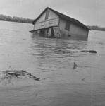
Hurricanes and weather systems that cause prolonged rainfall can result in flooding. Mud, silt and unknown contaminants in the water not only get everything dirty; they are also unhealthy. The dampness from the flooding promotes the growth of mildew on everything in the house. Here are some useful tips for responding to flooding and in helping to dry out your home.
You must begin the cleaning up process as soon as possible, as this will enable you to resume use of your homes and buildings as well as reduce further damage to the structure and its content.
DURING A FLOOD
If Indoors:
- Turn on battery-operated radio or television to get the latest emergency information.
- Get your preassembled emergency supplies.
- If told to leave, do so immediately.
If Outdoors:
- Climb to high ground and stay there.
- Avoid walking through any floodwaters. If it is moving swiftly, even water 6 inches deep can sweep you off your feet.
If in a Car:
- If you come to a flooded area, turn around and go another way.
- If your car stalls, abandon it immediately and climb to higher ground. Many deaths have resulted from attempts to move stalled vehicles.
BEFORE RE-ENTERING A FLOODED AREA:
Check with the electric and water companies to find out whether the utilities were shut off and whether they are still off. Avoid flooded areas if power lines are down.
After entering the flood area, don’t smoke or light open flames as flammable liquids may have gotten into the water and escaped. Gas might have collected in pockets of the building.
IMMEDIATELY AFTER ENTERING YOUR HOME:
Do not turn on any lights or appliances until a qualified electrician has checked the entire electrical system
Don’t enter a room where water is covering an electrical outlet or where a loose wire is hanging in water even if you have switched off the circuit breaker. Impurities or mud in the water can cause circuits to be energized and you could still receive an electrical shock.
DRYING OUT YOUR HOME
You must begin the cleaning up process as soon as possible, as this will enable you to resume use of your homes and buildings as well as reduce further damage to the structure and its content.
- Open up the house. If the weather permits, open up all doors and windows to facilitate circulation of air. Open closets, cupboard doors and drawers.
- Use fans – If the electricity supply has not been disrupted as a result of flooding experienced, fans help to circulate the air and dry out your home.
- To remove silt or dirt stains from the face of concrete walls, rinse thoroughly using a pressure hose and clear water. If stains still remain, soak the wall with clear water and then scrub using a household detergent and a brush with stiff bristles.
- The use of saw dust and wood chips in drying out garages and out houses is recommended.
- Until your house is reasonably dry, damage caused by mildew and decay will continue. The musty odour will stay forever if the house is not dried well. This however could be alleviated by using vinegar on mouldy/mildew areas and objects.
ELECTRICAL SYSTEMS, APPLIANCES AND EQUIPMENT
- Don’t attempt to operate or apply power to any appliance that has been in floodwater until it has cleaned and dried thoroughly and preferably checked by a qualified electrician.
- Coat metal surfaces with a thin coat of petroleum jelly or machine oil to prevent further rusting.
- Thoroughly clean the inside and outside of refrigerators and freezers. Wash inside surfaces with a solution of bleach and water to disinfect them and have a service man check the insulation for absorption of water.

BEDDING
Mattresses soaked with floodwater generally are damaged beyond use and should be discarded. If it has to be used temporarily, scrape off surface dirt and leave in the sunlight to dry as much as possible. Cover with rubber sheeting before use.

CARING FOR VALUABLE PAPERS AND BOOKS
- Wet paper attracts mould and will continue to deteriorate until it dries; attend to important documents as early as possible.

- Large quantities of paper, such as those in file cabinets affected by floodwaters, can be placed in a freezer to stop mould and deterioration. Separate into small bundles. When time allows, bundles can be removed, allow to thaw, and individual sheets separated and dried.
- Place books on end to dry and keep the leaves apart. If books are very damp, sprinkle cornstarch, or talcum powder between the leaves to take up the moisture, leave for several hours then brush off. Just before they are completely dry, apply a little heat, perhaps from a hair dryer between the pages to prevent musty odours.

Information provided in parts by the Environmental Health Unit, Ministry of Health. Adapted from article, “Drying Out Your Home after a Flood” - American Red Cross

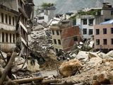
Earthquakes are caused by sudden movement in the earth’s surface. Accumulated energy in the form of waves vibrate the land surface and this can lead to damaged or destroyed buildings or infrastructure, floods from burst pipes or dams, fires from damage to electrical circuits, landslides and harm or death. The magnitude of an earthquake is the measurement of the energy released at the focal point or epicenter. The intensity of an earthquake is the destructive effect it may have. The Richter scale is the most common instrument of measurement. An earthquake of 3.1 intensity is unlikely to do much damage but one that is 6.1 or higher is much more intense and can topple buildings.
In the vast majority of earthquakes, most injuries and fatalities occur because the ground shaking dislodges loose objects in and on buildings. It is important to conduct an earthquake hazard hunt of your environment and eliminate objects that have the potential to cause injuries. Foresight and common sense are all that are needed as you go from room to room and imagine what would happen in an earthquake.
Common earthquake hazards include:
- What-nots
- Wardrobes
- Freestanding closets
- Dressers
- Bookcases
- Lamps
- Vases
- Figurines
- Hanging plants
- Mirrors
- Window A/C units
- Pictures mounted above bed
- Unfastened cabinet doors
- Unattached water heaters
- Gas or electric stoves
Being prepared makes a difference
Try to have the following on hand:
- Flashlights and battery operated radios
- First aid kits
- Fire extinguishers
- Drinking water
- Non-perishable food items (canned foods, dry crackers etc.)
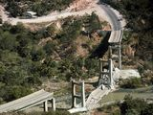
During the Earthquake
- Duck or drop down to the floor.
- Take cover under a sturdy desk, table, or other furniture. If that is not possible, seek cover against an interior wall and protect your head and neck with your arms. Avoid danger spots near windows, hanging objects, mirrors, or tall furniture.
- If you take cover under a sturdy piece of furniture, hold on to it and be prepared to move with it. Hold the position until the ground stops shaking and it is safe to move.
- If you're in a high-rise building, and you are not near a desk or table, move against an interior wall, and protect your head with your arms. Do not use the elevators.
- If you're outdoors, move to a clear area, away from trees, signs, buildings, or downed electrical wires and poles.
- If you're on a sidewalk near buildings, duck into a doorway to protect yourself from falling bricks, glass, plaster, and other debris.
- If you're driving, pull over to the side of the road and stop. Avoid overpasses, power lines, and other hazards. Stay inside the vehicle until the shaking is over
- If you're in a crowded store or other public place, do not rush for exits. Move away from display shelves containing objects that could fall.
- If you're in a wheelchair stay in it. Move to cover, if possible, lock your wheels, and protect your head with your arms.
- If you're in the kitchen, move away from the refrigerator, stove, and overhead cupboards.
- If you're in a stadium or theatre, stay in your seat and protect your head with your arms. Do not try to leave until the shaking is over. Then leave in a calm, orderly manner.
Immediately after the Earthquake
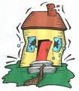
- Put on heavy soled shoes if you are barefooted (if you can access them).
- Check for injuries. Check yourself and those around you.
- Check for fires.
- Check stairs before using them. Stairs may have weakened during the earthquake.
- Exit buildings where possible and move into open spaces.
- If you are away from home, stay where you are and wait for aftershocks and information that may be transmitted over the radio.
- Do not drive unless you are driving away from tall buildings and bridges, and driving should only be to safety or to render immediate assistance. Roads should be kept open for emergency vehicles.

.
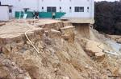
A landslide refers to the rapid downward sliding of a mass of earth and rock. The driving force behind all landslides is gravity. A landslide will occur when the gravitational pull increases when weight is added to the rock mass. Many kinds of events can trigger a landslide, such as:
- The over steepening of slopes by erosion associated with rivers or heavy rainfall which saturates soil and rock.
- Earthquakes that lead to the failure of weak slopes.
- Human activity such as deforestation, vegetation removal, and construction.
Likely Impact - Physical Damage
- Anything on top of or in the path of a Landslide will suffer damage
- Rubble may block roads, lines of communication or waterways. Indirect effect may include loss of productivity of agricultural or forest lands.
- Flooding.
- Reduced property values, destruction of buildings.
- Casualties- fatalities may occur due to slope failure.
Factors Contributing to Vulnerability
- Settlements built on steep slopes, softer soils and cliff tops
- Settlements built at the base of steep slopes, on mouths of streams from mountain valleys.
- Roads, communication lines in mountain areas
- Buildings with weak foundations
- Buried Pipelines and brittle pipes.
- Lack of understanding of landslide hazard
- Building without the approval of the relevant State Agencies
Precautionary Measures
The most destructive landslides generally occur rapidly and without warning so it is best to take precautionary measures to reduce your risk and loss. These include:
- If you have not yet constructed, find out the history of the area and determine whether you really ought to construct there.
- If you go ahead with construction, plant trees and shrubs that bind the soil on slopes and build retaining walls. In mudflow areas, build channels or deflection walls to direct the flow around buildings. There may be legal issues if you divert mudflow to your neighbour’s property.
- Plant or maintain well-rooted vegetation on slopes above and below your property. Don’t remove any trees or vegetation – unless the trees are diseased and pose a hazard.
- Refrain from doing so much paving that you channel storm run-off to where it will collect and saturate the soil.
- Maintain good drainage.
- Beware of building on steep slopes or cutting into them to level the ground for building. It must be done properly and, in some places, not at all. Always consult an expert in this regard.
- Putting too much weight on vulnerable areas can contribute to landslide hazards. So can vibrations, such as those caused by jackhammers, blasting or heavy trucks.
- Beware of changing the natural course of water-ways. This can cause problems, if not to you, then to others.
- Always refer to your Parochial Council for approval.
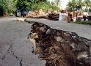
The forces of nature are beyond our control but if we reduce our vulnerability landslides do not have to become disasters.

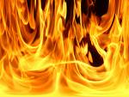
Fires and burns are the third leading cause of unintentional home injury and related deaths. Eighty five percent (85%) of fire deaths occur in the home, making fire prevention a top priority in every home. Being aware of the following safety advice could reduce the chance of fire in your home:
Prevent Fires Caused by Cooking:
[Cooking is the number one cause of home fires]:
- Always stay in the kitchen while cooking.
- Keep things that can burn, such as dishtowels, paper or plastic bags, and curtains at least three feet away from the stove.
- Loose-fitting clothes can touch a hot burner and catch on fire; use oven mitts.
- Do not leave electric irons, hot plates or other appliances plugged in as overheating can cause fire.
- Keep appliances clean, and wipe surfaces after spills. Clean stove surfaces and ovens regularly.
- Ensure microwaves have enough room to breathe, that all the vents are cleared of obstructions.
- If there is a microwave fire, keep the door closed and unplug the microwave. Make sure to have the microwave oven serviced before you use it again.
- If there is an oven fire, keep the door closed and turn off the heat. If the fire doesn't go out immediately, call the fire department.
- A grease fire occurs when oil or greasy foods are heated and ignite. The simplest way to fight a grease fire is to carefully slide a lid over the pan. Turn off the burner, don't move the pan, and keep the lid on until the pan cools completely.
Baking Soda may also be used to suffocate the fire. NEVER PUT WATER ON A GREASE FIRE. Water causes the grease to splatter and the fire to spread. Also, NEVER attempt to take a grease fire outdoors. It will be too hot to carry and you will drop it, causing a major house fire.
Prevent Fires Caused by Matches & Candles:
- Store matches and lighters in a locked cabinet; many young children are badly burned or die playing with matches and lighters.
- Only light candles when an adult is in the room. Do not allow children to keep candles or incense in their rooms.
- Always use stable candle holders made of material that won't catch fire, such as metal, glass, etc.
- Blow out candles when adults leave the room.
Prevent Fires Caused by Gasoline
- Gasoline is very dangerous. It is best not to keep any gasoline at home. If you must keep some, use a special safety container and do not store in or near domestic areas.
- If you can, keep the container in an outdoor shed away from your home. Close all the openings.
Keep Your Family Safe At Home
- Know how to put out a small pan fire by sliding a lid over the flames.
- Teach every family member to “Stop, Drop, Roll and Cool” if clothes catch fire by dropping immediately to the ground, crossing hands over your chest and rolling over and over or back and forth to put out the flames. Cool the burned area with cool water and seek medical attention for serious burns.
- Consider having a home fire extinguisher installed.
- Learn how and when to use a fire extinguisher.
- Get rid of stored newspaper or other unnecessary materials. Newspapers stored in a damp, warm place may ignite spontaneously.
- Install smoke detectors on every level of your home and outside of sleeping areas.
Electrical Distribution Equipment
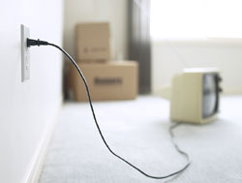
Wiring, outlets, switches, circuit breakers and other electrical devices are the third leading cause of home fires and the second leading cause of fire deaths.
- Replace or repair loose or frayed cords on all electrical devices.
- If outlets or switches feel warm, shut off the circuit and have them checked by an electrician.
- If you feel an extension cord is necessary, make sure that it is not frayed or worn. Do not run it under carpet or around doorways.
- Never overload a socket. The use of "octopus" outlets or "power bar", outlet extensions that accommodate several plugs, is strongly discouraged. Try to limit one high-wattage appliance into each individual outlet at a time.
- If a circuit breaker trips or a fuse blows frequently, cut down on the number of appliances on that line. Some overload signals include: dimming lights when an appliance goes on, fuses blowing frequently or shrinking TV picture.
- Ensure there's plenty of air space around home entertainment units such as the TV and stereo to avoid overheating.
Although some fires are caused by electrical system failures and appliance defects, many are caused by the misuse and poor maintenance of electrical appliances, incorrectly installed wiring, and overloaded circuits and extension cords.

What to Do If There is a Fire
- Raise an alarm to warn others of the emergency.
- On suspicion of fire, get children and helpless persons out of the building immediately.
- Get out of the building immediately.
- Do not get back into the burning building. You may not come out alive.
- If you are trapped in the building, lie flat on the ground and try to creep out; the air is clearer near the floor.
- Call the Jamaica Fire Brigade (JFB) at 110.
- No matter where you live or work, be familiar with all exits, including windows.
- Remember to turn off gas connections and electricity.

Conduct Fire Drills Regularly
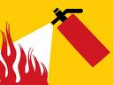
Fire drills enable us to react quickly and sensibly when confronted with a fire emergency. Inconvenient as this may be, every effort should be made to agree an evacuation plan to be followed in the event of a fire. This applies to your home, place of work or church. These drills should be practiced using all possible alternate safe routes that lead to open air and safety.
Contact the Office of Disaster Preparedness (ODPEM) for guidelines to establishing the appropriate plan for your particular situation.

Water Conservation
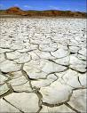
One of the impacts of drought on Jamaican life is a disruption to the normal workings of society in terms of quality of life. When drought is at hand, water conservation is critical. These tips have been put together as a reminder of the efforts we each can make to mitigate the need for harsh restrictive measures at times when water is scarce.
There are a number of ways to save water, and they all start with you. Be conscious of the amount of water you utilize and use less whenever you can.
In addition to conserving water during drought, it’s important to sanitize the water you use in order to avoid spreading disease. A good rule of thumb to follow is two drops of bleach for every quart of water or ½ a teaspoon bleach to every five gallons of water.
Remember....every little bit helps

Inside the home
- When washing dishes, don't let the water run while rinsing. Fill one sink with wash water and use a dish pan to hold rise water.
- When washing dishes, fill the sink basin or a large container and rinse when all of the dishes have been soaped and scrubbed.
- Use a glass for rinse water when brushing teeth instead of letting the faucet run. Shave the same way.
- Take short showers instead of baths and consider bathing small children together.
- Run washing machines and dishwashers only with full loads.
- When doing laundry, match the water level to the size of the load.
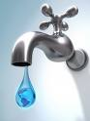
- Designate one glass for your drinking water each day or refill a water bottle. This will cut down on the number of glasses to wash.
- Soak pots and pans instead of letting the water run while you scrape them clean.
- Washing dark clothes in cold water saves both on water and energy while it helps your clothes to keep their colours.
- Teach your children to turn off faucets tightly after each use.
Save a drip today to prevent a drought tomorrow

Watch the numbers
- Fix leaks. A leak of merely 1 drop per second, wastes 2,400 gallons per year! Most leaks are easy to repair with some basic know-how and a few simple tools.
- Listen for dripping faucets and running toilets. Fixing a leak can save 300 gallons a month or more.
- If your toilet flapper doesn't close after flushing, replace it.

- Put food colouring in your toilet tank. If it seeps into the toilet bowl without flushing, you have a leak. Fixing it can save up to 1,000 gallons a month.
- We're more likely to notice leaks indoors, but don't forget to check outdoor pipes and plumbing for leaks.
- Shorten your shower by a minute or two and you'll save up to 150 gallons per month.
- When you are washing your hands, don't let the water run while you lather
- Turn off the water while you wash your hair to save up to 150 gallons a month.
- Turn off the water while you shave and save up to 300 gallons a month.
- Turn off the water while brushing your teeth and save 25 gallons a month.
- To save water and time, consider washing your face or brushing your teeth while in the shower.
- Keep a bucket in the shower to catch water as it warms up or runs. Use this water to flush toilets or water plants.
Monitor your water bill for unusually high use. Your bill and water meter are tools that can help you discover leaks

Recycle and Save
- Wash your fruits and vegetables in a pan of water instead of running water from the tap.
- Collect the water you use for rinsing fruits and vegetables, then reuse it to water house plants.
- When you give your pet fresh water, don't throw the old water down the drain. Use it to water your trees or shrubs.
- When cleaning out fish tanks, give the nutrient-rich water to your plants.
- Collect water from your roof to water your garden.
- Have your plumber re-route your gray water to trees and gardens rather than letting it run into the sewer line.
Water is life, use it well and live well
Looking ahead
- When buying new appliances, consider those that offer cycle and load size adjustments. They're more water and energy efficient.
- Know where your master water shut-off valve is located. This could save water and prevent damage to your home.
- Check for hidden leaks by turning off all outlets and then check to see if the meter is still running. If it is, there is a hidden leak.
When you save water, you save money on your utility bills too
Domestic Environment
- Leave lower branches on trees and shrubs and allow leaf litter to accumulate on the soil. This keeps the soil cooler and reduces evaporation.

- If you accidentally drop ice cubes when filling your glass from the freezer, don't throw them in the sink. Drop them in a house plant instead.
- When you have ice left in your cup from a take-out restaurant, don't throw it in the trash, dump it on a plant.
- For hanging baskets, planters and pots, place ice cubes under the moss or dirt to give your plants a cool drink of water and help eliminate water overflow.
- Use a broom instead of a hose to clean your driveway and sidewalk and save water every time.
- Share water conservation tips with friends and neighbours.
Save a drip for your family, your Community, your Country

These are intended mainly for women—but can serve all of us as we live in a violent society.
- The elbow is the strongest point on your body. If you are close enough to an attacker use it. The nose or face preferably.
- If a robber asks for your wallet or purse DO NOT HAND IT TO HIM, but toss it away from you….chances are he is more interested in your wallet/purse than in you and he will go for it…then RUN LIKE MAD IN THE OTHER DIRECTION.
- If you are ever thrown into the trunk of a car, kick out the back tail lights and stick out your arms waving like crazy. The driver won’t see you but others will. This has saved lives.
- Women have a tendency to get into cars after shopping, eating, working etc. and just sit doing their cheque books or making a list etc. DONT EVER DO THIS. The predator is watching you and this is the perfect opportunity for him to get in on the passenger side and pull a gun or knife and tell you to drive. As soon as you get into your vehicle, LOCK ALL DOORS AND DRIVE OFF
- If someone is in the car with a weapon, DO NOT DRIVE OFF—instead gun the engine and speed into anything, wrecking the car. You air bag will save you. As soon as the car crashes, jump out and run…this is better than having them find your body in a remote hillside place.
- In a parking lot/parking garage:
  - Be aware—look around you. Look in your car--passenger side and back seats and floor to make sure no one is hiding.
  - If you are parked next to a big van enter your car from the other side. Look carefully at the vehicle parked on the Driver’s side of your vehicle and the passenger side as well. If you see a male sitting in the other vehicle you may just want to walk back and have a guard accompany you to your vehicle. IT IS ALWAYS BETTER TO BE SAFE THAN SORRY and to be paranoid than dead!!
- Always take the elevator rather than the stairs. Stairways are awful places to be alone…especially at night.
- If a predator has a gun and you are not under his control RUN…he is much more likely to miss you if he fires….run in a zigzag pattern.
- If you hear a baby crying outside your premises in the night, call the police but DO NOT OPEN YOUR DOOR.
  - Do not be over sympathetic; it may get you raped or killed.
  - Some rapists are well dressed…others walk with a cane or a limp trying to get assistance….
BE CAREFUL ALWAYS!

….and just between us, here are
Nineteen Things Your Burglar Won't Tell You: **
- Of course I look familiar. I was here just last week cleaning your carpets, painting your shutters, or delivering your new refrigerator.
- Hey, thanks for letting me use the bathroom when I was working in your yard last week. While I was in there, I unlatched the back window to make my return a little easier.
- Love those flowers. That tells me you have taste ... and taste means there are nice things inside. Those yard toys your kids leave out always make me wonder what type of gaming system they have.
- Yes, I really do look for newspapers piled up on the driveway. And I might leave a pizza flyer in your front door to see how long it takes you to remove it.
- If decorative glass is part of your front entrance, don't let your alarm company install the control pad where I can see if it's set. That makes it too easy.
- A good security company alarms the window over the sink. And the windows on the second floor, which often access the master bedroom-and your jewellery. It's not a bad idea to put motion detectors up there too.
- It's raining, you're fumbling with your umbrella, and you forget to lock your door-understandable. But understand this: I don't take a day off because of bad weather.
- I always knock first. If you answer, I'll ask for directions somewhere or offer to clean your gutters. (Don't take me up on it.)
- Do you really think I won't look in your sock drawer? I always check dresser drawers, the bedside table, and the medicine cabinet.
- You're right: I won't have enough time to break into that safe where you keep your valuables. But if it's not bolted down, I'll take it with me.
- A loud TV or radio can be a better deterrent than the best alarm system.
- Sometimes, I carry a clipboard. Sometimes, I dress like a lawn guy and carry a rake. I do my best to never, ever look like a crook.
- The two things I hate most: loud dogs and nosy neighbours.
- I'll break a window to get in, even if it makes a little noise. If your neighbour hears one loud sound, he'll stop what he's doing and wait to hear it again. If he doesn't hear it again, he'll just go back to what he was doing. It's human nature.
- I'm not complaining, but why would you pay all that money for a fancy alarm system and leave your house without setting it?
- I love looking in your windows. I'm looking for signs that you're home, and for flat screen TVs or gaming systems I'd like. I'll drive or walk through your neighbourhood at night, before you close the blinds, just to pick my targets.
- Avoid announcing your vacation on your Facebook page. It's easier than you think to look up your address.
- To you, leaving that window open just a crack during the day is a way to let in a little fresh air. To me, it's an invitation.
- If you don't answer when I knock, I try the door. Occasionally, I hit the jackpot and walk right in.
** Sources:
Convicted burglars in North Carolina, Oregon, California, Kentucky
Chris McGoey - Security consultant
Richard T. Wright - Criminology professor at the University of Missouri-St. Louis, who interviewed 105 burglars for his book Burglars on the Job.

Jamaica has far too many accidents. Speeding and improper overtaking have been noted as being responsible for a major portion of our accidents.
The following guides could help us avoid an unfortunate situation:
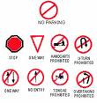
- Periodically walk around your vehicle checking that ALL lights are working and that indicator lights blink both back and front.
- Check that tyres are properly inflated
- Adjust all rear view mirrors while sitting correctly in the Driver’s seat.
- ALWAYS WEAR SEAT BELTS
- At dusk and later, always drive with your headlights on - vehicles are much more visible if their headlights are on.
- At a road juncture where there is a STOP sign—please come to a stop…..before starting off, turn your head to the left, then right, then straight ahead, then left again before proceeding
- When the light turns GREEN..look left, then right, then straight ahead before proceeding…some careless road users do run the lights, causing major accidents and fatalities.
- Every 6—8 seconds glance through the rear view mirrors. Be very careful when you decide to change lanes…rear view mirrors tend to make other vehicles look further away than they actually are.
- Check your engine fluid levels regularly
- Leave enough distance (usually3-4 car lengths) between yourself and the vehicle in front—in case that driver has to brake suddenly
- DON’T DRIVE AND USE THE CELL PHONE…If you must, pull over to a safe place and park. UNDER NO CIRCUMSTANCE MUST YOU TEXT WHILE DRIVING.
- Always tell others your itinerary when travelling out of town and do the occasional link…this could narrow the search in the event of an accident
- LEAVE EARLY AND REFRAIN FROM SPEEDING
- In rainy, misty weather ALL precautions are doubled..it is better to arrive late than not at all
- Do not ever overtake a line of traffic…(Undertakers love Overtakers!!)
- Always watch out for motorcycles..they seldom ever watch out for themselves!
My brothers and sisters drive carefully, the life you save might be your own!

